To,
Nursing & Midwifery Board of Ireland (NMBI),
Overseas Registration Department,
18/20 Carysfort Avenue, Blackrock,
Co. Dublin, A94 R299 - Ireland

SUB: EXPLANATION FOR THE DESIGNATION OF SIGNATORY IN THE EMPLOYMENT FORM

I, Anjana M Shaji, writing this letter to explain the designation of signatory in the NMBI employment form that was filled by my first employer - Inlaks and Budhrani Hospital-SVMMC.
I worked in Inlaks and Budhrani Hospital-SVMMC, Maharashtra State, India from 09th October 2012 to 09th October 2014. I was worked in the Infection Control Department as a Staff Nurse(ICN- Infection Control Nurse).
I have sent the NMBI Employment Form to the employer to fill in my details and indicated to the hospital authority that the form must be completed by the Nursing Director or Nursing Manager as stated in the form itself. But the form was filled out by Dr. Geeta Chitre who is the Infection Control Officer & Consultant Microbiologist in Inlaks and Budhrani Hospital-SVMMC.
I have requested them to get it refilled by the Nursing Director, but they refused, and I could not insist them more because I was informed by the employer that as per their policy, the Infection Control Officer is responsible for my NMBI employment form completion since I worked in Infection Control Department under her direct supervision and not with Nursing Department.
In addition to this letter, I have submitted a document I received from the employer that states the above.

Yours Sincerely, Date: March 15, 2022
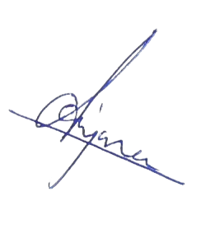
Name: Anjana M Shaji

